ROYAL PHOTOGRAPHIC SOCIETY
AUDIO VISUAL GROUP

ANNUAL GENERAL MEETING
26th September 2021 at 10:00AM via Zoom Conference Platform.

1. Welcome by the Chairman.
Edgar Gibbs opened the meeting and welcomed everyone.

2. Present:
Edgar Gibbs, Alastair Taylor, Ian Bateman, Keith Watson, Sheila Haycox, Andrew Gagg, Alan Tyrer, Peter Warner, Robert Albright, Brian Harvey, Mo Martin, Bryan Stubbs, Chris Bate, Raymond Hughes, Joan Ryder, Gerald Kitiyakara, Jenny ?, Derrick ?, Martin Fry, Jim Waddington, Richard Brown, Roy Appleby, Melanie Chalk, Howard Bagshaw, Carole Bagshaw, Eve Wilson, Lilian Webb, 970642440, Clive Rathband, Malcolm Gee, Jenny Gee.

Apologies:
Malcolm Imhoff, John Quinton, Jeff Noxon, Keith Brown, Martin Addison.

3. Minutes of the AGM 2020.
Roy Appleby expressed that his name was entered on last year’s Minutes as Roy ? and he wished it to be known that the question mark was Appleby.
Clive Rathband proposed acceptance of the Minutes and were seconded by Peter Warner.

4. Matters Arising.
Howard Bagshaw explained that during the Minutes of AGM 2020 he was uncertain regarding his continuation as Chairman of the National Audio Visual Championship. He confirmed to the membership today that he had notified the Committee of his intentions not to stand as Chairman of the NAVC as from here-on-in.
Malcolm Gee proposed that Matters Arising were accepted and seconded by Chris Bates.

5. Officers Reports.

5.1 Chairman Report:
Edgar commenced his report and acknowledged that 2020/21 had been a difficult time created from the Covid pandemic although the AV community had survived with thanks to Zoom for being a lifeline to many of us. This time last year the AGM was held during the first RPS Retrospective weekend, an event which was well received and kind comments had been received.
Since 2020, Edgar wished to record thanks to Martin Adison for seven beautifully set out editions of AV News e xtra. The website has gone from strength-to-strength with the archive information, programme and results helping to make it very interesting reading and a valuable historic recourse and Edgar recorded his thanks to Sheila Haycox for her excellent work in this area and for her speedy response to his requests. Edgar continued to record thanks to Andrew Gagg for his many professionally made graphics which have been used and for his advice given to the AV News Editor. Thanks, were then recorded to Alan Tyrer, for his previous work as Secretary and recently as Membership Secretary. Edgar explained that Alan had done sterling work for the AV Group over many years.
Ian Bateman joined the Committee as Vice Chairman last year and has promoted AV, ran AV events and is an excellent link with the PAGB. Along with Richard Brown, Ian is also on the Film, Video and Multimedia panel as AV Assessors.
Edgar continued to record his thanks to Alastair Taylor for being AV News Editor, Treasurer and contributor to AV News e xtra. Edgar felt that AV News was for the RPS to be proud of and something for the membership to look forward in reading. In addition, Alastair has become AV Group Representative to the RPS Membership Committee and a member of the Nominations Committee. Edgar thanked Alastair for all his work to the AV Group and the whole Society.
Thanks were then recorded to Peter Warner for his work in establishing a map of AV groups throughout the UK which is a difficult job with continual ongoing work.
Edgar then remembered lost ones within the AV community over the past year adding that the Committees thoughts and prayers are with everyone.
It was then mentioned that over the following months the Committee will consider whether to have an IAVF in 2022, hopefully live and to bring it back in-line with the correct year that it should be in, or to hold the NAVC next year. AV News and AV News e xtra will continue.
Edgar concluded his report by expressing a general thank you to the Committee for their support and also from the AV community. He wished we can all meet up face-to-face at live AV events next year.

At this point, Peter Warner paid thanks to Sheila Haycox for her work within the AV Group Map on the website and asked the meeting if anyone knew of anyone who judges and/or gives talks to clubs on the AV genre to please let him know so that they can be added to the map.

5.2 Treasurer Report:
See Appendix A.
Alastair shared his Zoom screen to the meeting showing the groups balance sheet. He explained that many of the financial changes came alongside the changes which the RPS had done in order to consolidate groups finances, where previously there had been 40 separate bank accounts.
Major points which Alastair highlighted to the membership was the main AV Group Account which had pulled back a loss in 2019 to a modest profit in 2020, and was achieved by reducing AV News to 3 editions a year from 4 editions, but with the same number of pages. The main savings were through postage of the magazine. Other notable savings were from Committee meetings which are now held on Zoom rather than travelling.
There had been no NAVC during the past financial year and the monies showing were from corrections on previous accounts. The IAVF account shows a loss and Alastair reported that this was due to payment to the venue and to FIAP patronage, both of which have been rolled over to 2021/22.
Alastair concluded his report by explaining that the role of Treasurer had become a whole lot easier due to the amendments made by RPS in consoling the finances.

Howard Bagshaw raised a question and asked Alastair whether the balance sheet should show the year 2020 over the columns for “Account 2” and “Account 3”? Alastair agreed that it should and confirmed the actual monies which the group has available is £9,230.32 + £2,341.73 + £6,688.18
Alastair also added that in future reports he will continue to show the three accounts rather than amalgamate then all in one. He felt it important for the members to see the finances of IAVF and NAVC as well as the Groups overall funds.

Edgar explained to the meeting that he, along with Alastair, had put pressure on the RPS at previous head office meetings going back to 2018 to make the finances easier and more controllable. Alastair added that all other RPS groups had now took on the same system as the AV Group had done.

Acceptance of the Accounts, Proposed by Malcolm Gee and Second by Clive Rathband. A vote was then carried by a show of hands. There were no abstentions.

5.3 Secretary Report:
See Appendix B.
Before Keith Watson commenced his report, he thanked Alastair for the help and support he gave whilst Keith was struggling with the Treasurer role. He extended that gratitude to Edgar and Alan Tyrer.
Keith concluded his report by asking anyone to contact him should he be able to offer assistance within the role of Secretary.

Clive Rathband asked for membership number details. Alastair and Alan answered by saying approximately 180 memberships plus about 50 additional subscribers (AV News).

5.4 AV News Editor:
See Appendix C.
Alastair Taylor felt that the construction of AV News was about right and that he receives many compliments and so far, no complaints. He explained the new feature, “AV Lives” which featured Ron Davies to start with. He also relayed some interesting facts from Judith Kimber’s piece.
Alastair asked for some new contributors to come forward to write some new topic journals. Alastair thanked those who are already and have giving some great articles. He finished his report and explained that there is a digital archive for AV News and Alan Tyrer will continue to keep the back catalogue.
Clive Rathband gave thanks to Alastair for a superb publication. Brian asked for articles regarding computer requirements. A conversation then commenced on the pros and cons of MP4 files.

5.5 Festival Director Report
Prior to the IAVF report, Edgar gave thanks to Howard Bagshaw for his incredible work on the National Audio-Visual Championships over the years, for finding excellent venues and all the other details required for an event such as this to operate without a hitch.
Edgar explained the difficult decision in making this year’s festival (IAVF) to be held live or online. The decision was held until late as possible so that the Covid restrictions could be monitored. This year’s IAVF had 65 entries from 13 different countries. FIAP was happy to roll-over the patronage from 2020 and the jury were happy to pre-judge the entries, with thanks to Howard for overseeing it. Edgar did not have current financial figures for this year’s events although he felt it should cut even. The RPS President, Simon Hill, will attend the final day of the IAVF to say a few words.
Edgar recorded thanks to his wife, Linda for all of her hard and often unseen work which she has put in to this years IAVF, and he was sad that the team were not able to meet afterwards for a celebratory dinner.

5.6 Membership Secretary Report:
Alan Tyrer reported that the AV Group membership during the past 5 years has reduced from circa 200 to 180, which equates to approximately 10% reduction. Alan felt that this figure is probably inline with other groups although some of it was due to uncertainties within RPS AV Group over the Distinction process and also the problems created by Covid should be to blame.
Alan finished by thanking for the time which he had enjoyed during his years on the AV Committee and felt they were a good team. The meeting attendees gave Alan a round of applause.

Edgar asked Ian Bateman to give an update on the progress of the new Distinctions process for AV. Ian explained that they were in the final stages of the first one in the new system and felt that he couldn’t give too much detail at this time. The Chair of the Multimedia panel had sent out all of the applications to the members who have reviewed them individually and sent their initial votes back. A Zoom meeting has been arranged by the panel although Ian does not know how this will be as it is the first time the process has been done in this way.
Martin Fry asked the question regarding the RPS website for Multimedia quality and innovation requirements that there was no mention of Audio Visual. Martin also questioned the RPS requirement how one applicant can possibly make a film of 90 minutes or more single handed and without assistance from other people. Martin added that he feels the RPS AV Group should “pull strings” and make clear that AV Distinctions cannot be run in this manner and that the AV Group should be made able to run the process themselves.
Edgar responded by saying that the AV Group had been involved for 18 months with the RPS over this matter and for the time being the new and current process should be allowed to run before any criticism can be put forward. Ian Bateman agreed with Edgar and added that it was doubtful the RPS would condone the AV Group undertaking the Distinction process by itself.
Jenny Gee added that she cannot see how the work of an individual AV producer can be compared to a film made by a production team of people.
Edgar finalised and told everyone that all of these points raised will be put forward to the RPS once the present Distinction process has completed.

6. Election of Officers:

The nominations were:

6.1 Chair - Edgar Gibbs.
6.2 Vice Chair - Ian Bateman.
6.3 Secretary - Keith Watson.
6.4 Treasurer - Alastair Taylor.

Edgar asked the meeting if it was acceptable for a vote en bloc. This was accepted and the nominations were proposed by Clive Rathband and second by Alastair Taylor.
A vote was undertaken by the meeting attendees and unanimously accepted.
Edgar read out the remaining Committee Members; Sheila Haycox, Andrew Gagg, Martin Addison, Peter Warner. A vote of agreement was unanimous and Edgar requested the Minutes were amended to record it.
Edgar thanked everyone for standing again for the Committee and thanked everyone for the work which they have done and will be doing over the next year.

7. To Consider Other Proposals:
No other nominations had been received.

8. Any Other Business:
Roy Appleby said he found it difficult having too many agenda and meetings too close together. Edgar explained that the IAVF is always held on this weekend which is when the school is closed and the only weekend when the Centenary Hall is available to us. It was tradition that the AV Group AGM took place during a live event, either the IAVF or NAVC. Howard Bagshaw felt that an AGM held on Zoom is the best way of attracting as many members as possible to attend. He suggested that future AGMs could continue to take place on Zoom with retaining the greatest number of participants. This would permit the AGM to be held on a different weekend than the IAVF or NAVC and avoid any agenda clashes.
Edgar confirmed that this idea will be taken into account when the date is made for 2022 AGM. Richard Brown added that it would be impossible to arrange a future AGM date on Zoom and still not have some clashes of interest. Alastair Taylor reminded us that September is about the latest the AGM can officially take place.

9. Date of Next Meeting:
TBA

10. Close.
Edgar thanked everyone for their contributions to the meeting and closed the meeting at 11:00AM.

Appendix A – Treasurers Report:

Treasurer’s Report – 2021 AGM
The accounts presented are for the year ending 31 December 2020 and as far as I am concerned represent an accurate picture of the AV Group finances.
Points to note are as follows:
- The main AV Group account shows a positive margin of £395.44. This reverses deficits in previous years and the positive change is attributed to savings made in postage on account of reducing the AV News Journal from 4 to 3 editions a year. In addition, the committee is now using Zoom for its meetings which makes a considerable saving on travel expenses. The income from group membership is marginally lower than in previous years reflecting the shifting demographics of group membership.
- There has been no activity in the NAVC account during 2020 other than a minor positive adjustment made by the RPS Finance department.
- The IAVF account shows a loss of £592.77 which is attributed to costs associated with the planning for the 2021 International Festival which will even themselves out in future accounts. A deposit for the venue at Cheltenham was paid and will be rolled forward to a future festival.
The position with accounting is subject to significant changes from RPS Central Office with the merging of all accounts into a central account. This is ongoing during 2021. All payments are now undertaken by RPS Staff which is reducing the burden for the AV Group Treasurer significantly. Even though the accounts will be merged into one, this will still permit the three individuals accounts to be reconciled individually.
Alastair Taylor
AV Group Treasurer – September 2021

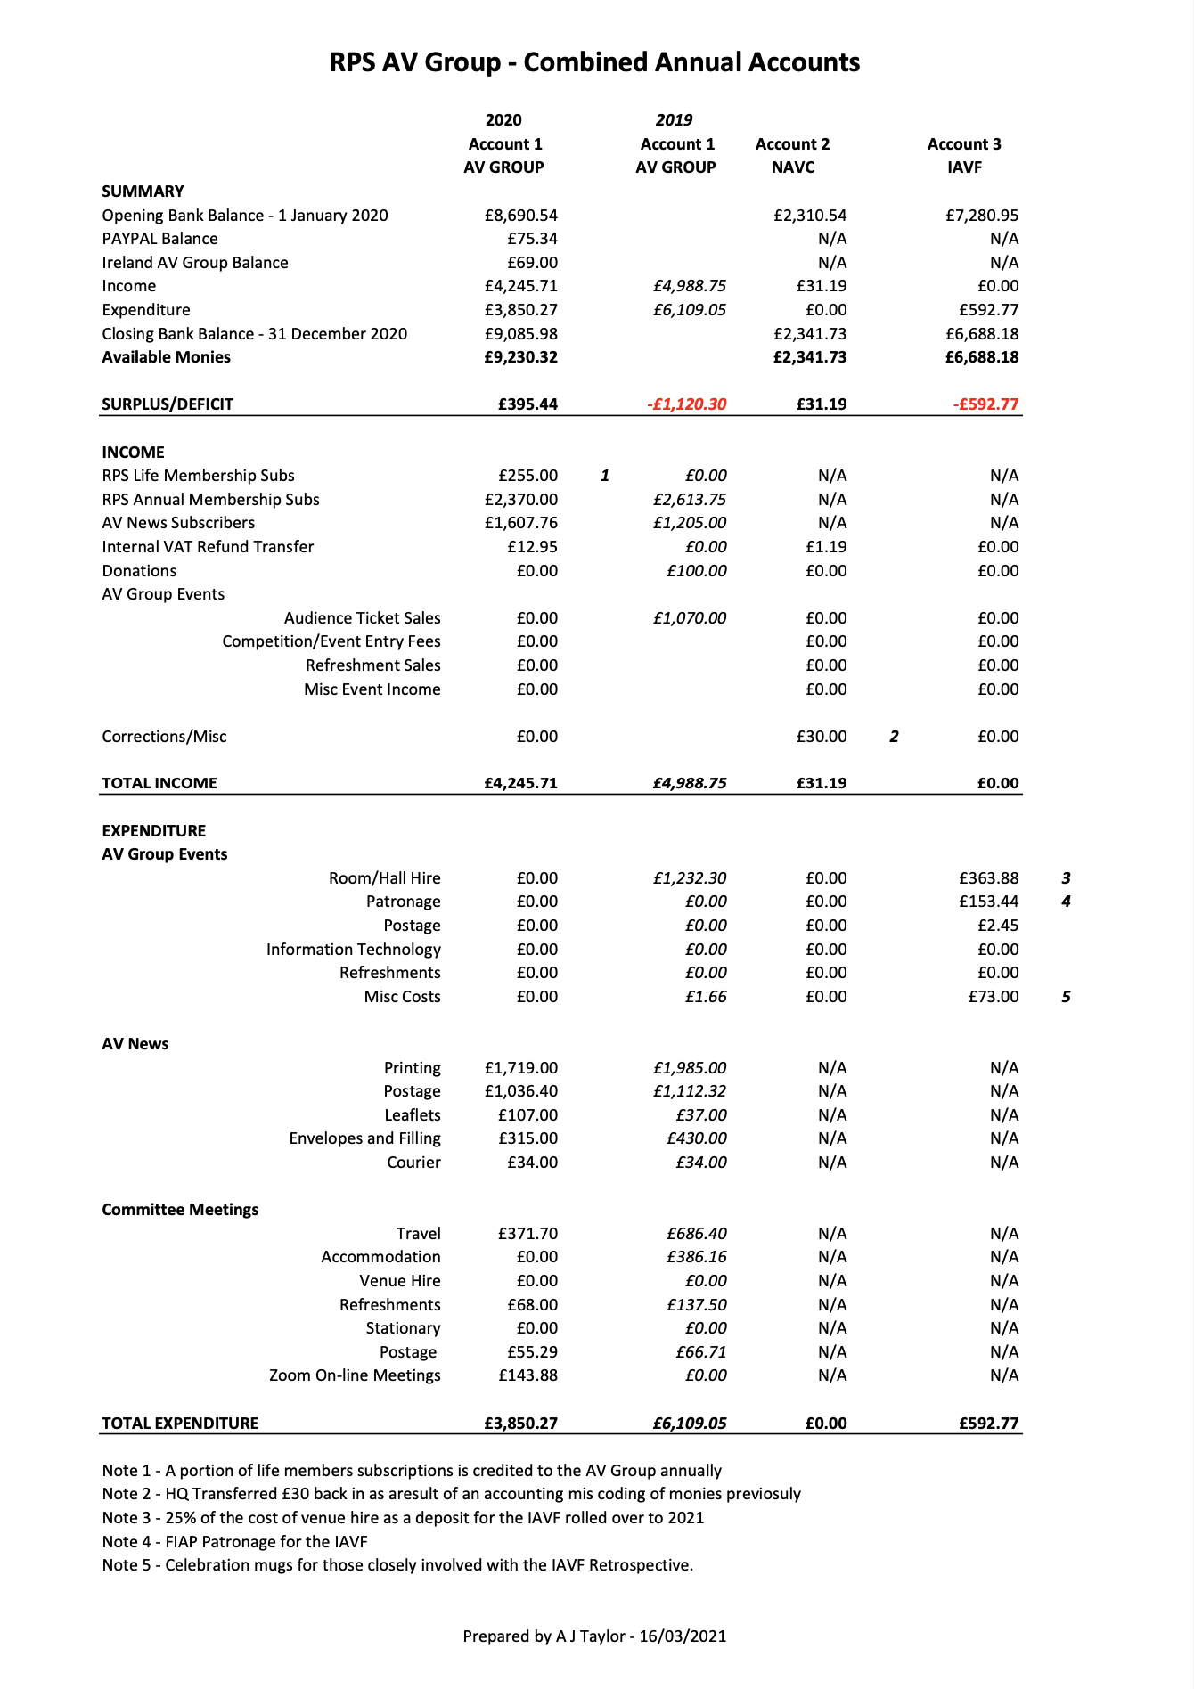

Appendix B – Secretary Report:

Secretary Report

Having commenced this role of Secretary at last years Annual General Meeting I wish to thank Alan Tyrer, our retiring Secretary and most recently our Membership Secretary on the very smooth transaction of passing the position and relevant information over to me. More importantly, thank you Alan for being there for me whilst I learn this position given to me and for the advice when I needed it most.

Alan relieved most of the membership roles for me, and now the membership side of things will pass to Alastair Taylor, which makes great sense as it is he of course who takes our membership money and sends out the AV News magazine.

I do not have much to report. The Secretary role appears very undemanding although I treat it as an honour to be able to serve you by doing this. If I uphold this position half as good as Alan did then I will be a happy person.
Please never hesitate in contacting me should I be able to assist you as Secretary and I will always endeavour to do my best for you, the RPS AV Group and the AV community as a whole, which I have found to be the kindest and friendliest of groups, and may that continue to be so.

Keith Watson
Secretary – Royal Photographic Society Audio Visual Group.

Appendix C – AV News Editor Report:

AV News Editors Report
AV news has been well received by members. There was a reduction from 4 to 3 editions per year in 2020. The page count of each edition was increased to compensate for the change in editions so overall, the content is similar in terms of quantity.
The editor continues to receive a sufficient range of contents with some new ideas coming through over the next few editions. However, more copy is always welcome, so he encourages members to get involved with the provision of copy.
The current editors plan to continue in the role for the next year at least
Alastair Taylor
Editor AV News – September 2021

